Git Aliases

What Are Git Aliases?
# Source: AI Source: Provided by: [Data Path: Persons Table -> ID Column: 1, Name_En Column: Motasem Essam] -> From: [ChatGPT] on [3/6/2026]
Git aliases are custom shortcuts for Git commands.
They let you create shorter or more convenient names for commands you use often.
Think of them like nicknames for Git commands.

🔹 Why Use Git Aliases?
# Source: AI Source: Provided by: [Data Path: Persons Table -> ID Column: 1, Name_En Column: Motasem Essam] -> From: [ChatGPT] on [3/6/2026]
Instead of typing:
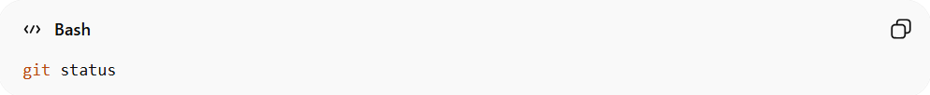
git status
You can type:
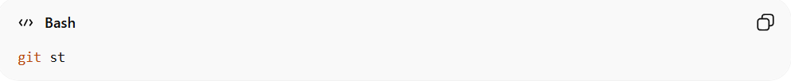
git st
Much faster 🚀

🔹 How to Create a Git Alias
# Source: AI Source: Provided by: [Data Path: Persons Table -> ID Column: 1, Name_En Column: Motasem Essam] -> From: [ChatGPT] on [3/6/2026]
You create aliases using git config.

Example 1: Simple Shortcut
# Source: AI Source: Provided by: [Data Path: Persons Table -> ID Column: 1, Name_En Column: Motasem Essam] -> From: [ChatGPT] on [3/6/2026]
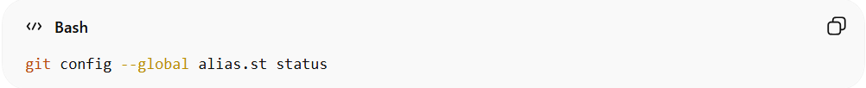
git config --global alias.st status
Now you can run:
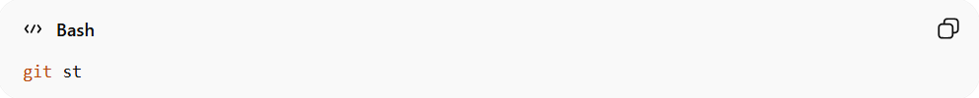
git st

Example 2: Shortcut for Commit
# Source: AI Source: Provided by: [Data Path: Persons Table -> ID Column: 1, Name_En Column: Motasem Essam] -> From: [ChatGPT] on [3/6/2026]
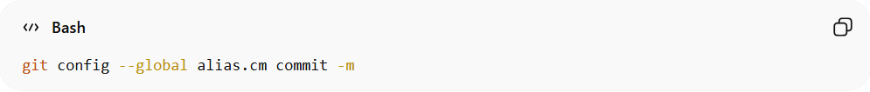
git config --global alias.cm commit -m
Now you can write:
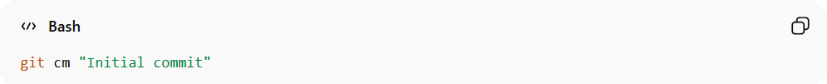
git cm "Initial commit"
Instead of:
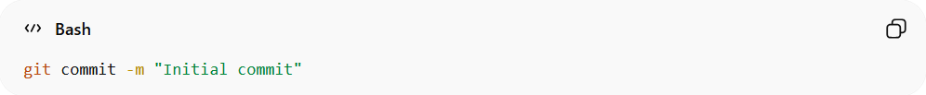
git commit -m "Initial commit"

Example 3: Pretty Log View (Very Popular)
# Source: AI Source: Provided by: [Data Path: Persons Table -> ID Column: 1, Name_En Column: Motasem Essam] -> From: [ChatGPT] on [3/6/2026]
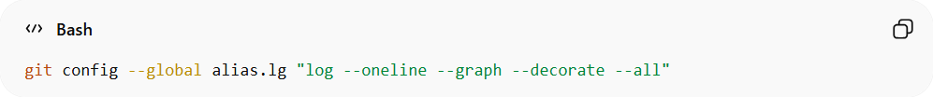
git config --global alias.lg "log --oneline --graph --decorate --all"
Then run:
git lg
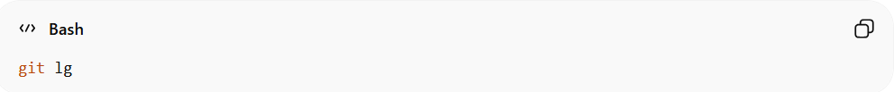
This shows a clean, visual commit history.

🔹 Where Aliases Are Stored
# Source: AI Source: Provided by: [Data Path: Persons Table -> ID Column: 1, Name_En Column: Motasem Essam] -> From: [ChatGPT] on [3/6/2026]
If you use --global, they are saved in:
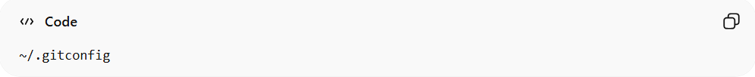
~/.gitconfig
If you omit --global, they are saved inside:
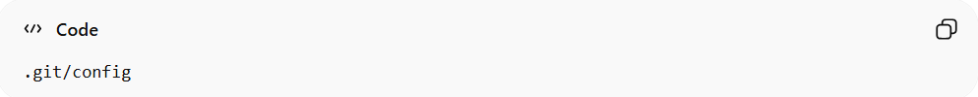
.git/config
(for that repository only)

🔹 View Your Aliases
# Source: AI Source: Provided by: [Data Path: Persons Table -> ID Column: 1, Name_En Column: Motasem Essam] -> From: [ChatGPT] on [3/6/2026]
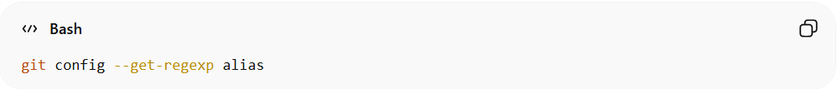
git config --get-regexp alias

🔹 Delete an Alias
# Source: AI Source: Provided by: [Data Path: Persons Table -> ID Column: 1, Name_En Column: Motasem Essam] -> From: [ChatGPT] on [3/6/2026]
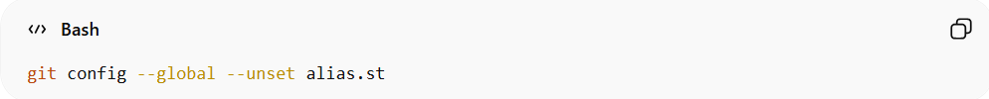
git config --global --unset alias.st

🔹 Advanced: Shell Aliases
# Source: AI Source: Provided by: [Data Path: Persons Table -> ID Column: 1, Name_En Column: Motasem Essam] -> From: [ChatGPT] on [3/6/2026]
You can even run full shell commands:
git config --global alias.last "log -1 HEAD"
Or:
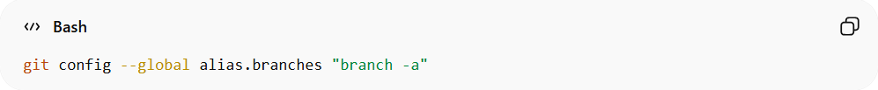
git config --global alias.branches "branch -a"

Example

Create a Git Alias
# Source: ScreenShots Source: Provided by: [Persons Table -> ID Column: 1, Name_En Column: Motasem Essam] -> Tool: [Lightshot Program] -> From [Operating System: Windows] on [3/6/2026]
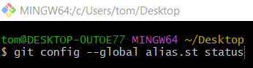
git config --global alias.st status
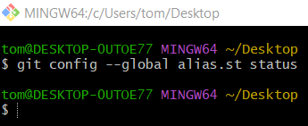
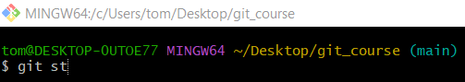
git st
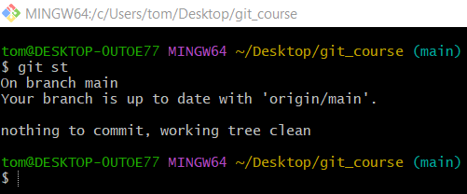

Where Aliases Are Stored
# Source: ScreenShots Source: Provided by: [Persons Table -> ID Column: 1, Name_En Column: Motasem Essam] -> Tool: [Lightshot Program] -> From [Operating System: Windows] on [3/6/2026]
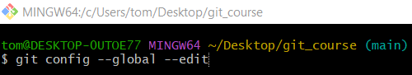
git config --global --edit
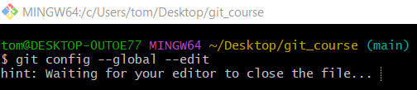
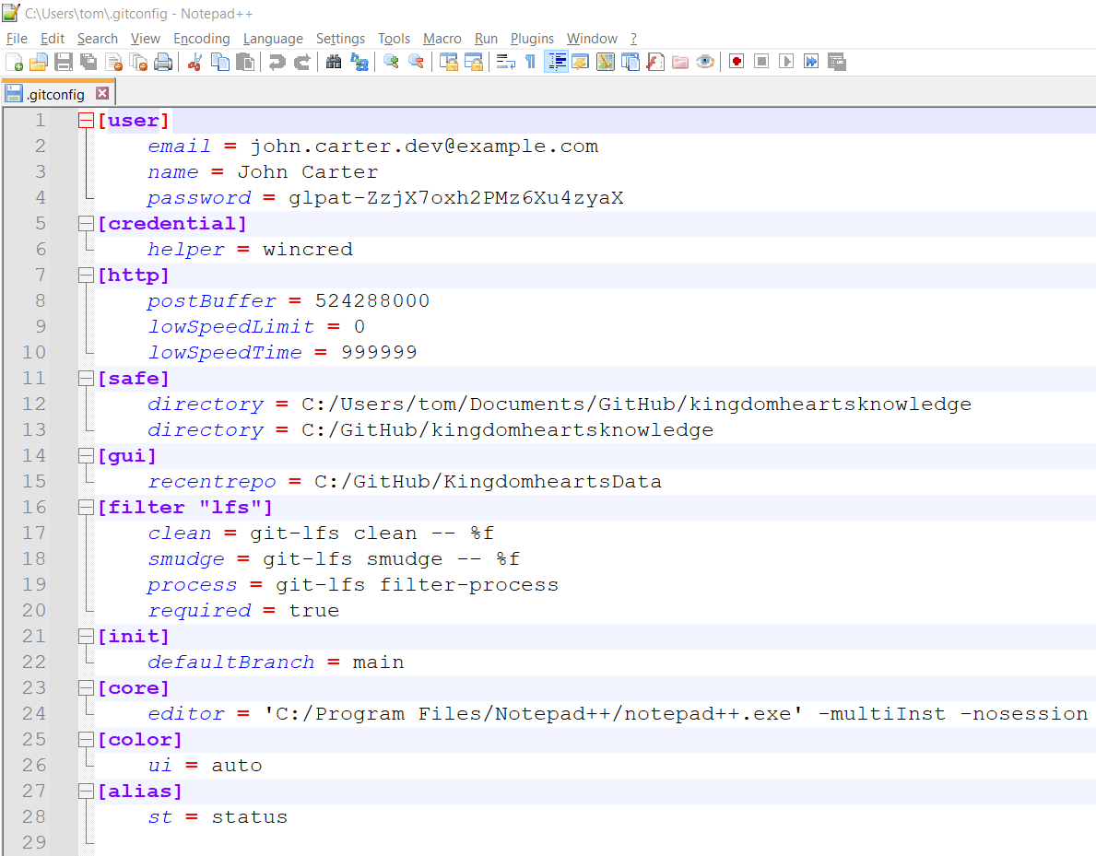
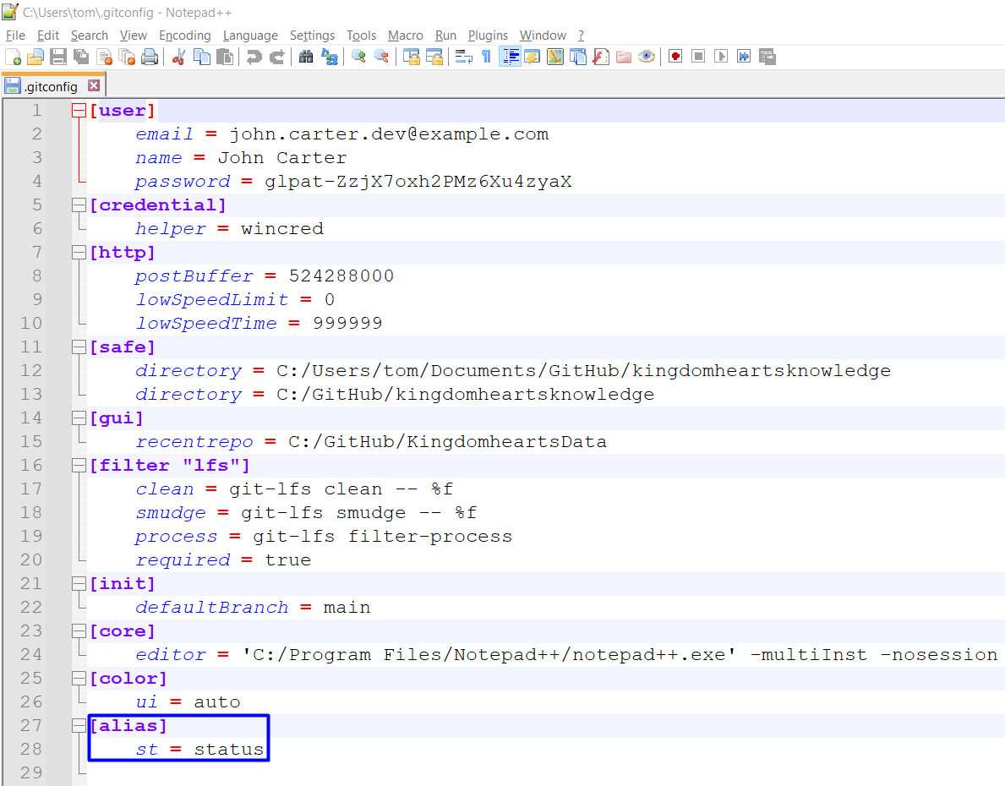

View Your Aliases
# Source: ScreenShots Source: Provided by: [Persons Table -> ID Column: 1, Name_En Column: Motasem Essam] -> Tool: [Lightshot Program] -> From [Operating System: Windows] on [3/6/2026]
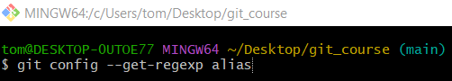
git config --get-regexp alias
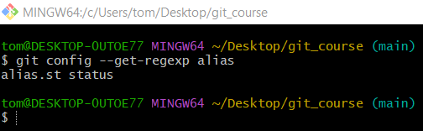

Delete an Alias
# Source: ScreenShots Source: Provided by: [Persons Table -> ID Column: 1, Name_En Column: Motasem Essam] -> Tool: [Lightshot Program] -> From [Operating System: Windows] on [3/6/2026]
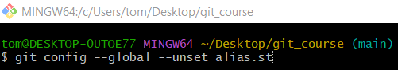
git config --global --unset alias.st
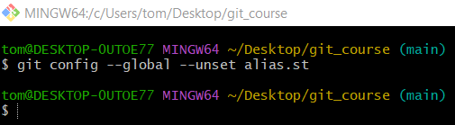

Advanced: Shell Aliases
# Source: ScreenShots Source: Provided by: [Persons Table -> ID Column: 1, Name_En Column: Motasem Essam] -> Tool: [Lightshot Program] -> From [Operating System: Windows] on [3/6/2026]
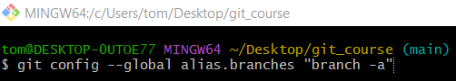
git config --global alias.branches "branch -a"
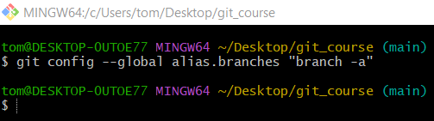
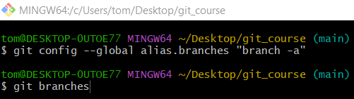
git branches
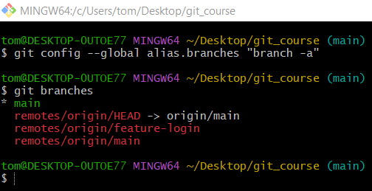

🔹 Summary
# Source: AI Source: Provided by: [Data Path: Persons Table -> ID Column: 1, Name_En Column: Motasem Essam] -> From: [ChatGPT] on [3/6/2026]
Git aliases:
- Save time
- Reduce typing
- Improve workflow
- Can be local or global
- Are completely customizable

